Practical 6 | ALPHA BETA PRUNING | Date: 00/07/2025
Aim: | To implement alpha beta pruning on given graph
Requirement: | Python IDE
Code: | 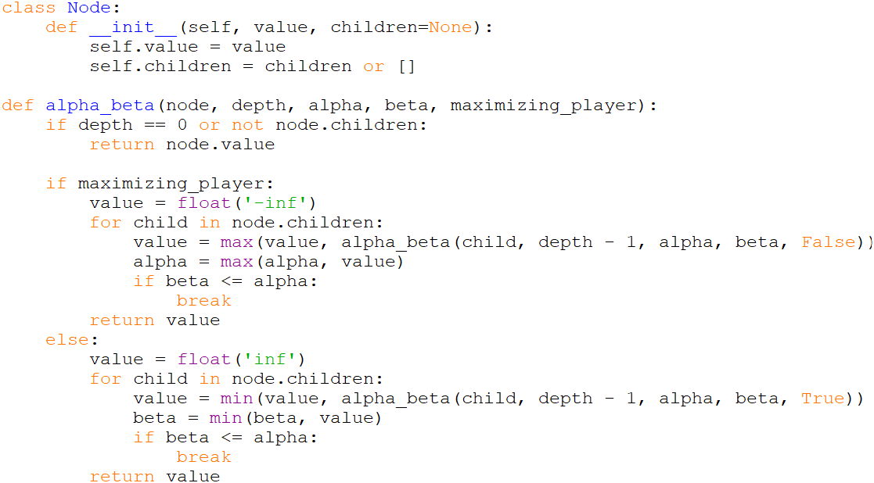  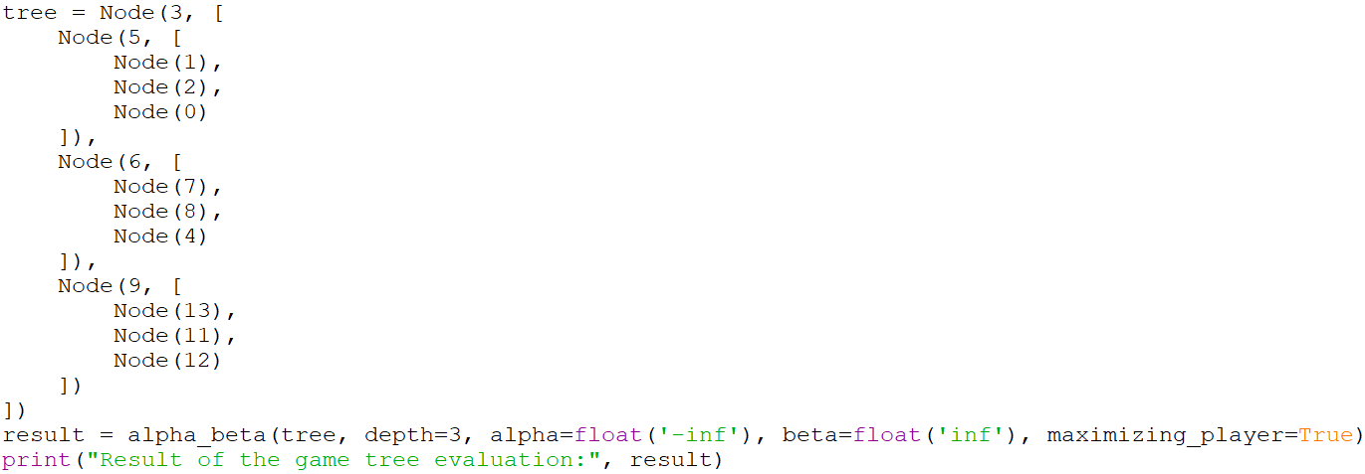
Screenshots:
Result: | Alpha beta pruning has been implemented using python.
Date of Submission: |  | Sign:

